**Smart gardening (A homegrown irrigation system for the homegrown veggies)**

**Objective:**

An irrigation system is a way to allow water to lightly spray the roots of the plants, either on the surface of the soil or directly into the root zone, using a solenoid valve. Anyway, of course found that the market price of the system is relatively small local coverage. Therefore, this paper suggests a smart home design a garden irrigation system that uses ready-to-use, energy efficient, and cost effective devices. Raspberry Pi, i.e. performance in this program is combined with many such sensors such as soil moisture sensors, ultrasonic sensors, and light sensors. The proposed system is designed to reduce costs, reduce wastewater, and reduced the human interface. In this paper, the relay is used to control solenoid valve replacement. The program also was able to measure soil moisture and control the solenoid valve according to individual needs. Continuing with Graphical User Interface (GUI) uses the Android app to activate irrigation work. An email notification is also sent to a home user for the purpose of general warning or criticism jobs. Test settings tested and verified that the system can effectively control and monitor soil humidity levels in the test field.

**Hardware & Software Requirements:**

Raspberry pi

Soil moisture sensor:

Light-dependent Resistor (LDR)

HC-SR04 Ultrasonic sensor

Wi-Pi Adapter

Solenoid Valve

**Project Flow:**

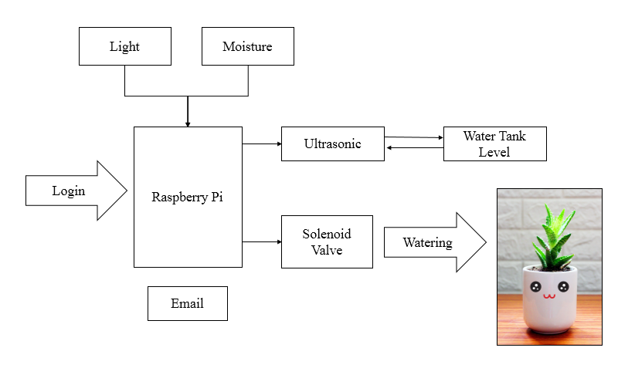

**Proposed System:**

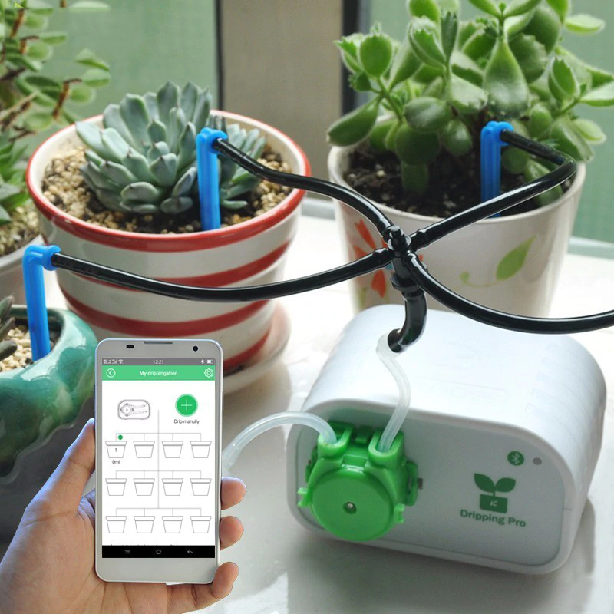

**Stack Holders:**

The first main consumers are those who are practicing gardening, since food scarcity has started across the globe, many regions, urban areas and even the poor have started implementing the gardenin. Then comes the industrialists who make the model so easy that, urban gardening establishes new forms of public–private partnerships for the utilization, design and financing of particular (public and private) spaces in cities. New green areas are created. Others would like to reconnect with nature. So comes the software developers in designin the platform for the users to make it easy for them. Finally researchers would come to in contact with all sorts of departments in order to customize the model to make it even better than before.